eszközök és konfigurációk
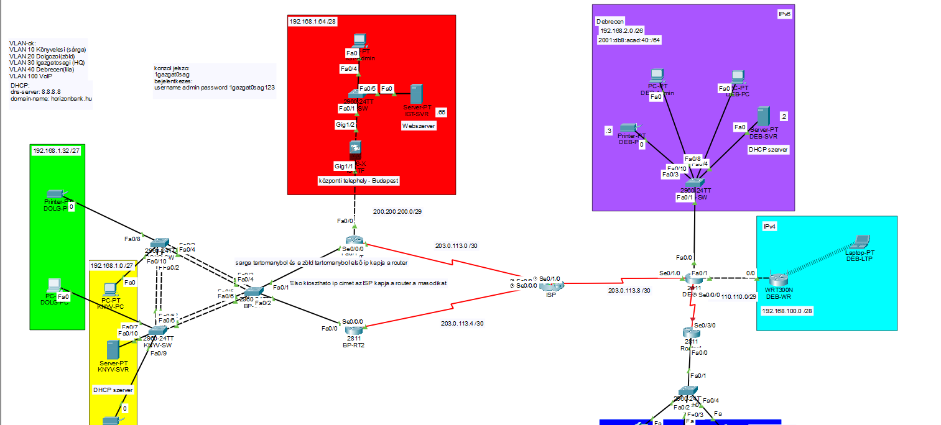
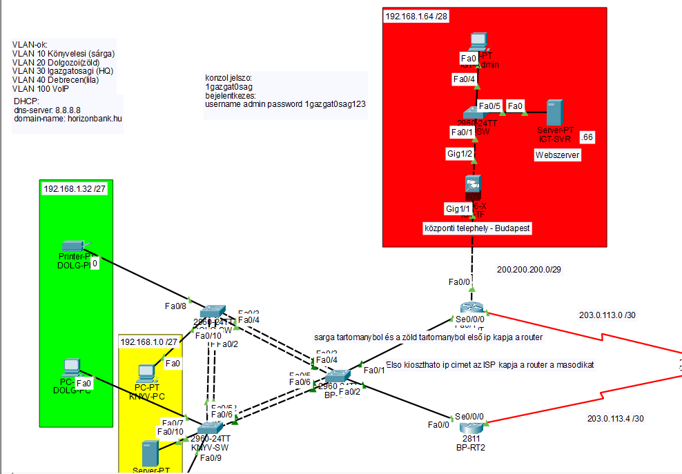
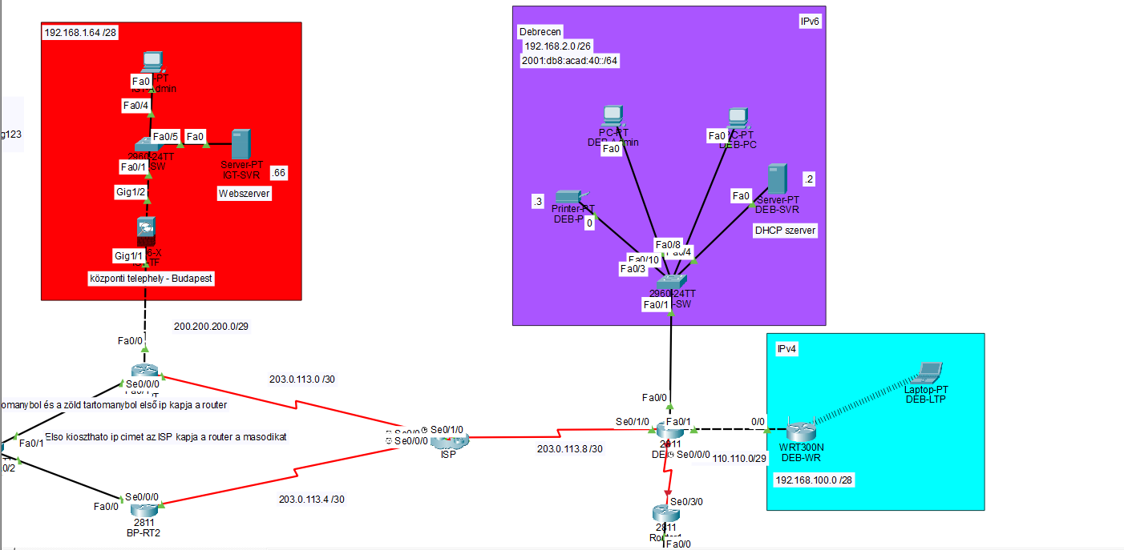
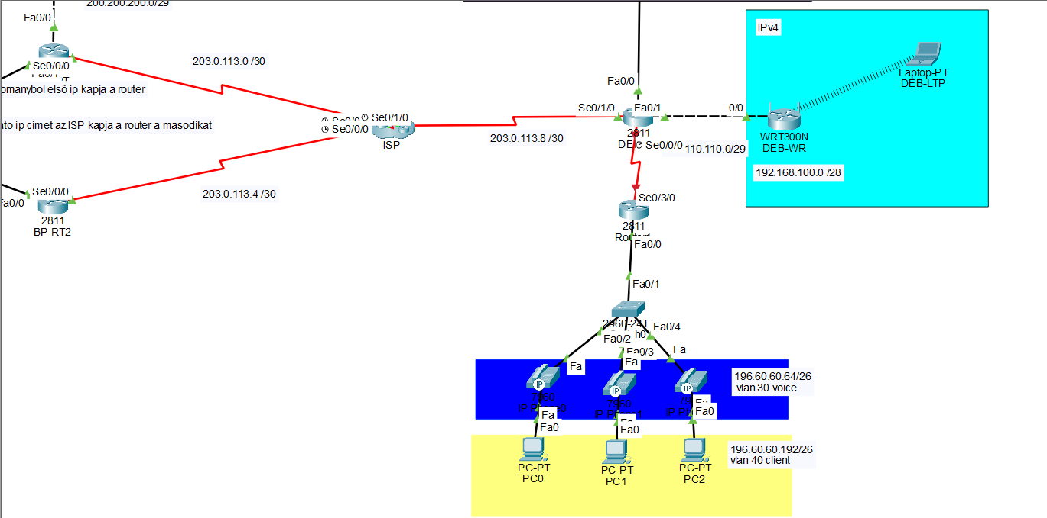

DOLG-PC:
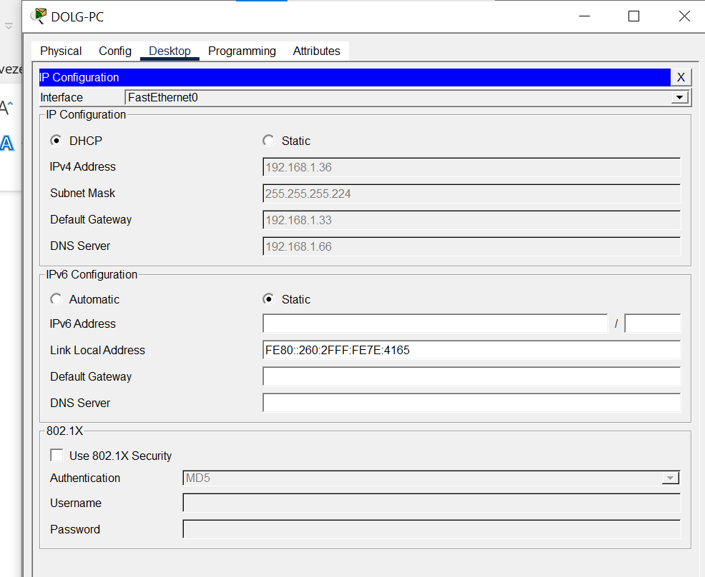

DOLG-PR:
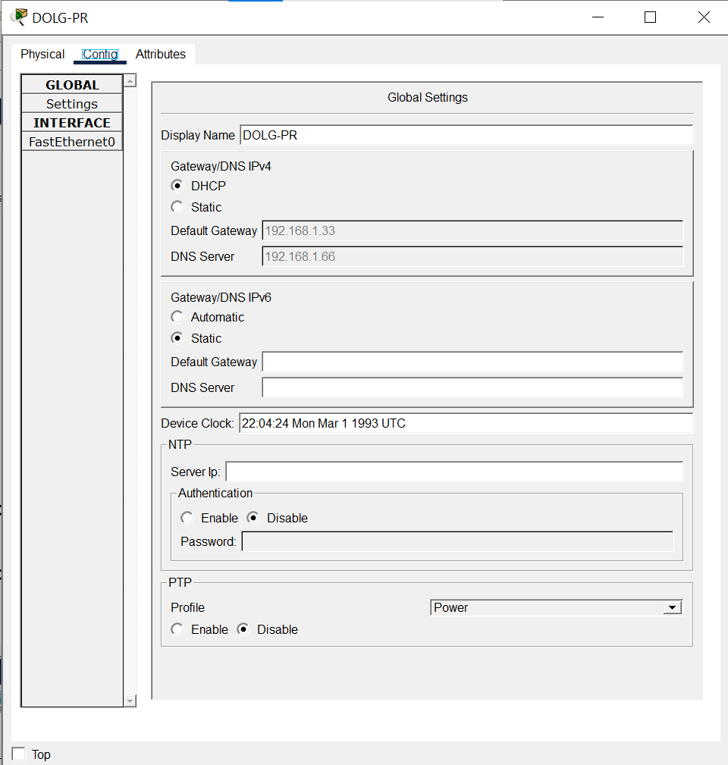

KNYV-PC:
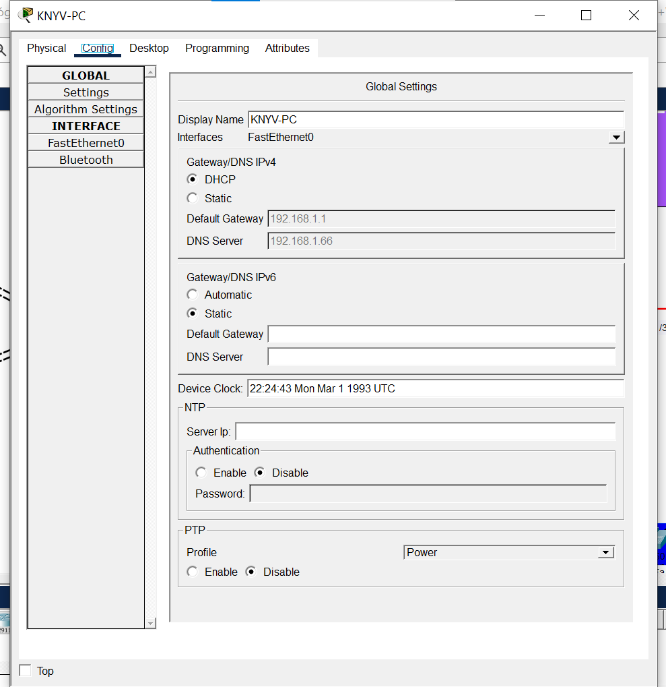

KNYV-SVR:
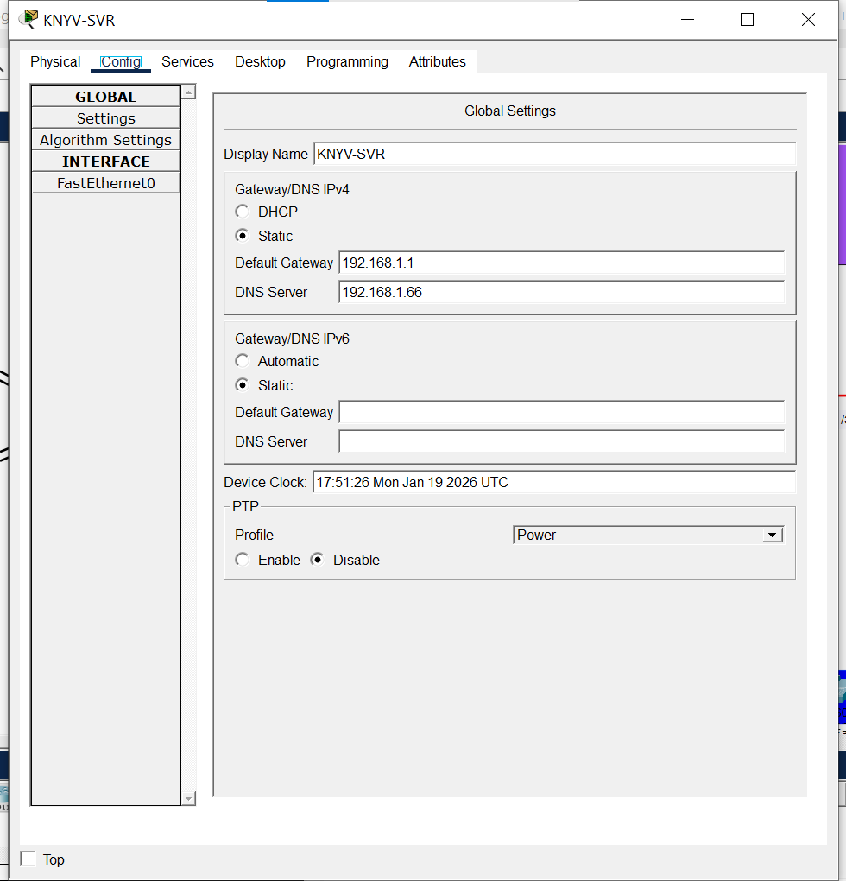

KNYV-PR:
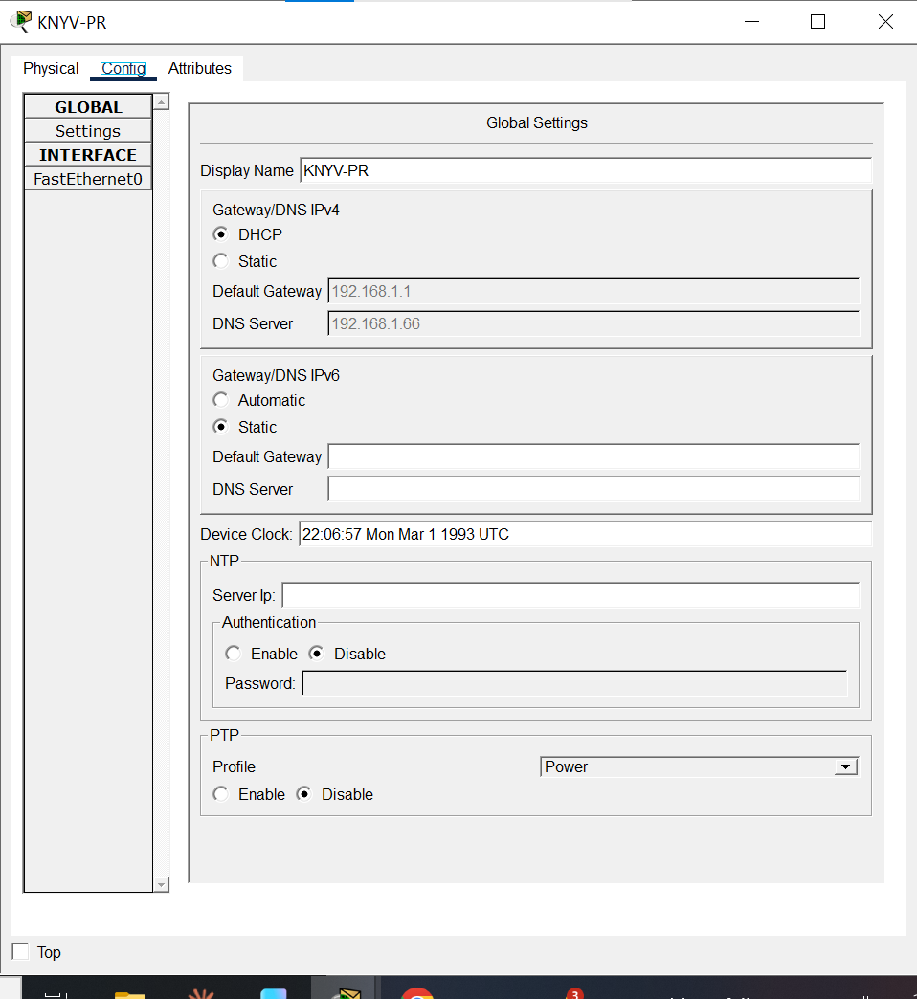
DOLG-SW:
DOLG-SW#show running-config
Building configuration...

Current configuration : 2571 bytes
!
version 15.0
no service timestamps log datetime msec
no service timestamps debug datetime msec
service password-encryption
!
hostname DOLG-SW
!
enable secret 5 $1$mERr$4sQaZg8gZWvXUt4hXKENY1
!
!
!
clock timezone CET 1
!
no ip domain-lookup
ip domain-name horizonbank.hu
!
!
!
spanning-tree mode rapid-pvst
spanning-tree extend system-id
!
interface Port-channel1
switchport trunk allowed vlan 10,20,30,100
switchport mode trunk
!
interface Port-channel2
switchport trunk allowed vlan 10,20,30,100
switchport mode trunk
!
interface FastEthernet0/1
switchport trunk allowed vlan 10,20,30,100
switchport mode trunk
channel-group 2 mode active
!
interface FastEthernet0/2
switchport trunk allowed vlan 10,20,30,100
switchport mode trunk
channel-group 2 mode active
!
interface FastEthernet0/3
switchport trunk allowed vlan 10,20,30,100
switchport mode trunk
channel-group 1 mode passive
!
interface FastEthernet0/4
switchport trunk allowed vlan 10,20,30,100
switchport mode trunk
channel-group 1 mode passive
!
interface FastEthernet0/5
!
interface FastEthernet0/6
!
interface FastEthernet0/7
switchport access vlan 20
switchport mode access
spanning-tree portfast
spanning-tree bpduguard enable
!
interface FastEthernet0/8
switchport access vlan 20
switchport mode access
spanning-tree portfast
spanning-tree bpduguard enable
!
interface FastEthernet0/9
switchport access vlan 20
switchport mode access
spanning-tree portfast
spanning-tree bpduguard enable
!
interface FastEthernet0/10
switchport access vlan 10
switchport mode access
spanning-tree portfast
spanning-tree bpduguard enable
!
interface FastEthernet0/11
!
interface FastEthernet0/12
!
interface FastEthernet0/13
!
interface FastEthernet0/14
!
interface FastEthernet0/15
!
interface FastEthernet0/16
!
interface FastEthernet0/17
!
interface FastEthernet0/18
!
interface FastEthernet0/19
!
interface FastEthernet0/20
!
interface FastEthernet0/21
!
interface FastEthernet0/22
!
interface FastEthernet0/23
!
interface FastEthernet0/24
!
interface GigabitEthernet0/1
!
interface GigabitEthernet0/2
!
interface Vlan1
no ip address
shutdown
!
banner motd ^C Az illetektelen hozzaferes TILOS! ^C
!
!
!
line con 0
password 7 082543620E491F471B205C0A2078287D29
logging synchronous
login
exec-timeout 5 0
!
line vty 0 4
exec-timeout 5 0
password 7 08051C420E2F110E2658000A793F147C666015
logging synchronous
login
transport input ssh
line vty 5 15
exec-timeout 5 0
password 7 08051C420E2F110E2658000A793F147C666015
logging synchronous
login
transport input ssh
!
!
!
!
end
KNYV-SW:
KNYV-SW#show run
Building configuration...

Current configuration : 2551 bytes
!
version 15.0
no service timestamps log datetime msec
no service timestamps debug datetime msec
service password-encryption
!
hostname KNYV-SW
!
enable secret 5 $1$mERr$L/SRVeUhrXMktV.USsfWe0
!
!
!
clock timezone CET 1
!
no ip domain-lookup
ip domain-name horizonbank.hu
!
!
!
spanning-tree mode rapid-pvst
spanning-tree extend system-id
!
interface Port-channel2
switchport trunk allowed vlan 10,20,30,100
switchport mode trunk
!
interface Port-channel3
switchport trunk allowed vlan 10,20,30,100
switchport mode trunk
!
interface FastEthernet0/1
switchport trunk allowed vlan 10,20,30,100
switchport mode trunk
channel-group 2 mode passive
!
interface FastEthernet0/2
switchport trunk allowed vlan 10,20,30,100
switchport mode trunk
channel-group 2 mode passive
!
interface FastEthernet0/3
!
interface FastEthernet0/4
!
interface FastEthernet0/5
switchport trunk allowed vlan 10,20,30,100
switchport mode trunk
channel-group 3 mode active
!
interface FastEthernet0/6
switchport trunk allowed vlan 10,20,30,100
switchport mode trunk
channel-group 3 mode active
!
interface FastEthernet0/7
switchport access vlan 20
switchport mode access
spanning-tree portfast
spanning-tree bpduguard enable
!
interface FastEthernet0/8
switchport access vlan 10
switchport mode access
spanning-tree portfast
spanning-tree bpduguard enable
!
interface FastEthernet0/9
switchport access vlan 10
switchport mode access
spanning-tree portfast
spanning-tree bpduguard enable
!
interface FastEthernet0/10
switchport access vlan 10
switchport mode access
spanning-tree portfast
spanning-tree bpduguard enable
!
interface FastEthernet0/11
!
interface FastEthernet0/12
!
interface FastEthernet0/13
!
interface FastEthernet0/14
!
interface FastEthernet0/15
!
interface FastEthernet0/16
!
interface FastEthernet0/17
!
interface FastEthernet0/18
!
interface FastEthernet0/19
!
interface FastEthernet0/20
!
interface FastEthernet0/21
!
interface FastEthernet0/22
!
interface FastEthernet0/23
!
interface FastEthernet0/24
!
interface GigabitEthernet0/1
!
interface GigabitEthernet0/2
!
interface Vlan1
no ip address
shutdown
!
banner motd ^C Az illetektelen hozzaferes TILOS! ^C
!
!
!
line con 0
password 7 080A1C40100F561B17182A570603701B09
logging synchronous
login
exec-timeout 5 0
!
line vty 0 4
exec-timeout 5 0
password 7 080A1C40300F561B260E002A791F
logging synchronous
login
transport input ssh
line vty 5 15
exec-timeout 5 0
password 7 080A1C40300F561B260E002A791F
logging synchronous
login
transport input ssh
!
!
!
!
end

BP-SW:

BP-SW#show run
Building configuration...

Current configuration : 2299 bytes
!
version 15.0
no service timestamps log datetime msec
no service timestamps debug datetime msec
service password-encryption
!
hostname BP-SW
!
enable secret 5 $1$mERr$lSWvxesqZ5vL2jCry9lyA1
!
!
!
clock timezone CET 1
!
no ip domain-lookup
ip domain-name horizonbank.hu
!
!
!
spanning-tree mode rapid-pvst
spanning-tree extend system-id
spanning-tree vlan 10,20,30,100 priority 4096
!
interface Port-channel1
switchport trunk allowed vlan 10,20,30,100
switchport mode trunk
!
interface Port-channel3
switchport trunk allowed vlan 10,20,30,100
switchport mode trunk
!
interface FastEthernet0/1
switchport trunk allowed vlan 10,20,30,100
switchport mode trunk
!
interface FastEthernet0/2
switchport trunk allowed vlan 10,20,30,100
switchport mode trunk
!
interface FastEthernet0/3
switchport trunk allowed vlan 10,20,30,100
switchport mode trunk
channel-group 1 mode active
!
interface FastEthernet0/4
switchport trunk allowed vlan 10,20,30,100
switchport mode trunk
channel-group 1 mode active
!
interface FastEthernet0/5
switchport trunk allowed vlan 10,20,30,100
switchport mode trunk
channel-group 3 mode passive
!
interface FastEthernet0/6
switchport trunk allowed vlan 10,20,30,100
switchport mode trunk
channel-group 3 mode passive
!
interface FastEthernet0/7
!
interface FastEthernet0/8
!
interface FastEthernet0/9
!
interface FastEthernet0/10
!
interface FastEthernet0/11
!
interface FastEthernet0/12
!
interface FastEthernet0/13
!
interface FastEthernet0/14
!
interface FastEthernet0/15
!
interface FastEthernet0/16
!
interface FastEthernet0/17
!
interface FastEthernet0/18
!
interface FastEthernet0/19
!
interface FastEthernet0/20
!
interface FastEthernet0/21
!
interface FastEthernet0/22
!
interface FastEthernet0/23
!
interface FastEthernet0/24
!
interface GigabitEthernet0/1
!
interface GigabitEthernet0/2
!
interface Vlan1
no ip address
shutdown
!
banner motd ^C Az illetektelen hozzaferes TILOS! ^C
!
!
!
line con 0
password 7 08037C7D1E4811140134075404317404
logging synchronous
login
exec-timeout 5 0
!
line vty 0 4
exec-timeout 5 0
password 7 08035C4B5C0D33032B3438572625
logging synchronous
login
transport input ssh
line vty 5 15
exec-timeout 5 0
password 7 08035C4B5C0D33032B3438572625
logging synchronous
login
transport input ssh
!
!
!
!
end

BP-RT:
BP-RT#show run
Building configuration...

Current configuration : 2362 bytes
!
version 15.1
no service timestamps log datetime msec
no service timestamps debug datetime msec
service password-encryption
security passwords min-length 8
!
hostname BP-RT
!
!
!
enable secret 5 $1$mERr$r4GaONU0/xJ.8eITME7tY.
!
!
!
clock timezone CET 1
!
!
!
!
ip cef
no ipv6 cef
!
!
!
!
license udi pid CISCO2811/K9 sn FTX10179WL1-
!
!
!
crypto isakmp policy 10
encr aes 256
authentication pre-share
group 5
lifetime 1800
!
crypto isakmp key HORIZONKULCS address 203.0.113.10
!
!
!
crypto ipsec transform-set BP-DEB esp-aes esp-sha-hmac
!
crypto map HORIZONMAP 10 ipsec-isakmp
set peer 203.0.113.10
set pfs group5
set security-association lifetime seconds 900
set transform-set BP-DEB
match address VPNLIST
!
!
!
!
!
!
no ip domain-lookup
ip domain-name horizonbank.hu
!
!
spanning-tree mode pvst
!
!
!
!
!
!
interface FastEthernet0/0
ip address 200.200.200.1 255.255.255.248
duplex auto
speed auto
!
interface FastEthernet0/1
no ip address
duplex auto
speed auto
!
interface FastEthernet0/1.10
encapsulation dot1Q 10
ip address 192.168.1.1 255.255.255.224
ip helper-address 192.168.1.3
standby 10 ip 192.168.1.30
standby 10 priority 110
standby 10 preempt
!
interface FastEthernet0/1.20
encapsulation dot1Q 20
ip address 192.168.1.33 255.255.255.224
ip helper-address 192.168.1.3
standby 20 ip 192.168.1.62
standby 20 priority 110
standby 20 preempt
!
interface Serial0/0/0
ip address 203.0.113.2 255.255.255.252
crypto map HORIZONMAP
!
interface Serial0/0/1
no ip address
clock rate 2000000
shutdown
!
interface Serial0/1/0
no ip address
clock rate 2000000
shutdown
!
interface Serial0/1/1
no ip address
clock rate 2000000
shutdown
!
interface Vlan1
no ip address
shutdown
!
router ospf 1
router-id 1.1.1.1
log-adjacency-changes
network 200.200.200.0 0.0.0.7 area 0
network 192.168.1.0 0.0.0.31 area 0
network 192.168.1.32 0.0.0.31 area 0
network 203.0.113.0 0.0.0.3 area 0
!
ip classless
!
ip flow-export version 9
!
!
ip access-list extended VPNLIST
permit ip 203.0.113.0 0.0.0.3 203.0.113.8 0.0.0.3
!
banner motd ^C Az illetektelen hozzaferes TILOS! ^C
!
!
!
!
line con 0
exec-timeout 5 0
password 7 08037C7C1D325519085B00517D7876
logging synchronous
login
!
line aux 0
!
line vty 0 4
exec-timeout 5 0
password 7 08037C713B0D3A21061233307927
logging synchronous
login
transport input ssh
!
!
!
end

BP-RT2:
BP-RT2#show run
Building configuration...

Current configuration : 1680 bytes
!
version 15.1
no service timestamps log datetime msec
no service timestamps debug datetime msec
service password-encryption
security passwords min-length 8
!
hostname BP-RT2
!
!
!
enable secret 5 $1$mERr$5tYBF.2T1TOuv..KvRLrk1
!
!
!
clock timezone CET 1
!
!
!
!
ip cef
no ipv6 cef
!
!
!
!
license udi pid CISCO2811/K9 sn FTX10172V33-
!
!
!
!
!
!
!
!
!
!
!
no ip domain-lookup
ip domain-name horizonbank.hu
!
!
spanning-tree mode pvst
!
!
!
!
!
!
interface FastEthernet0/0
no ip address
duplex auto
speed auto
!
interface FastEthernet0/0.10
encapsulation dot1Q 10
ip address 192.168.1.2 255.255.255.224
standby 10 ip 192.168.1.30
!
interface FastEthernet0/0.20
encapsulation dot1Q 20
ip address 192.168.1.34 255.255.255.224
standby 20 ip 192.168.1.62
!
interface FastEthernet0/1
no ip address
duplex auto
speed auto
shutdown
!
interface Serial0/0/0
ip address 203.0.113.6 255.255.255.252
!
interface Serial0/0/1
no ip address
clock rate 2000000
shutdown
!
interface Serial0/1/0
no ip address
clock rate 2000000
shutdown
!
interface Serial0/1/1
no ip address
clock rate 2000000
shutdown
!
interface Vlan1
no ip address
shutdown
!
router ospf 1
router-id 2.2.2.2
log-adjacency-changes
network 192.168.1.32 0.0.0.31 area 0
network 192.168.1.0 0.0.0.31 area 0
network 203.0.113.4 0.0.0.3 area 0
!
ip classless
!
ip flow-export version 9
!
!
!
banner motd ^C Az illetektelen hozzaferes TILOS! ^C
!
!
!
!
line con 0
exec-timeout 5 0
password 7 08034D7E1D26370317395E3B01240A223639
logging synchronous
login
!
line aux 0
!
line vty 0 4
exec-timeout 5 0
password 7 0813581C3F0D1C28260E202A793F
logging synchronous
login
transport input ssh
!
!
!
end

IGT-TF:
IGT-TF#show run
ASA Version 9.6(1)
!
hostname IGT-TF
enable password Vy0wEO5/w193Aqbp encrypted
names
!
interface GigabitEthernet1/1
nameif outside
security-level 0
ip address 200.200.200.2 255.255.255.248
!
interface GigabitEthernet1/2
nameif inside
security-level 100
ip address 192.168.1.65 255.255.255.240
!
interface GigabitEthernet1/3
no nameif
no security-level
no ip address
shutdown
!
interface GigabitEthernet1/4
no nameif
no security-level
no ip address
shutdown
!
interface GigabitEthernet1/5
no nameif
no security-level
no ip address
shutdown
!
interface GigabitEthernet1/6
no nameif
no security-level
no ip address
shutdown
!
interface GigabitEthernet1/7
no nameif
no security-level
no ip address
shutdown
!
interface GigabitEthernet1/8
no nameif
no security-level
no ip address
shutdown
!
interface Management1/1
management-only
no nameif
no security-level
no ip address
shutdown
!
!
!
access-list PERMIT extended permit ip 192.168.2.0 255.255.255.224 192.168.1.64 255.255.255.240
access-list PERMIT extended permit ip 192.168.1.32 255.255.255.224 192.168.1.64 255.255.255.240
!
!
access-group PERMIT out interface inside
aaa authentication ssh console LOCAL
!
username admin password 3bl4Ll3beGamEvh4 encrypted
!
class-map inspection_default
match default-inspection-traffic
!
policy-map type inspect dns preset_dns_map
parameters
message-length maximum 512
policy-map global_policy
class inspection_default
inspect dns preset_dns_map
inspect ftp
inspect tftp
!
service-policy global_policy global
!
telnet timeout 5
ssh 192.168.1.64 255.255.255.240 inside
ssh timeout 3
!
!
crypto ipsec ikev1 transform-set BP-DEB esp-aes esp-sha-hmac
!
crypto map HORIZONMAP 10 set ikev1 transform-set BP-DEB
!
router ospf 1
router-id 5.5.5.5
log-adjacency-changes
network 192.168.1.64 255.255.255.240 area 0
network 200.200.200.0 255.255.255.248 area 0
!

IGT-SW:
IGT-SW(config)#do sh run
Building configuration...

Current configuration : 1530 bytes
!
version 15.0
no service timestamps log datetime msec
no service timestamps debug datetime msec
service password-encryption
!
hostname IGT-SW
!
enable secret 5 $1$mERr$a7Tr9f4W6HIrZRa6/5NpF/
!
!
!
clock timezone CET 1
!
no ip domain-lookup
ip domain-name horizonbank.hu
!
!
!
spanning-tree mode pvst
spanning-tree extend system-id
!
interface FastEthernet0/1
!
interface FastEthernet0/2
!
interface FastEthernet0/3
!
interface FastEthernet0/4
!
interface FastEthernet0/5
!
interface FastEthernet0/6
!
interface FastEthernet0/7
!
interface FastEthernet0/8
!
interface FastEthernet0/9
!
interface FastEthernet0/10
!
interface FastEthernet0/11
!
interface FastEthernet0/12
!
interface FastEthernet0/13
!
interface FastEthernet0/14
!
interface FastEthernet0/15
!
interface FastEthernet0/16
!
interface FastEthernet0/17
!
interface FastEthernet0/18
!
interface FastEthernet0/19
!
interface FastEthernet0/20
!
interface FastEthernet0/21
!
interface FastEthernet0/22
!
interface FastEthernet0/23
!
interface FastEthernet0/24
!
interface GigabitEthernet0/1
!
interface GigabitEthernet0/2
!
interface Vlan1
no ip address
shutdown
!
banner motd ^C Az illetektelen hozzaferes TILOS! ^C
!
!
!
line con 0
password 7 08086B7A36325519085B003B227F1712
logging synchronous
login
exec-timeout 5 0
!
line vty 0 4
exec-timeout 5 0
password 7 08086B7A1F0D1C3B43055F
logging synchronous
login
transport input ssh
line vty 5 15
exec-timeout 5 0
password 7 08086B7A1F0D1C3B43055F
logging synchronous
login
transport input ssh
!
!
!
!
end

IGT-SVR:
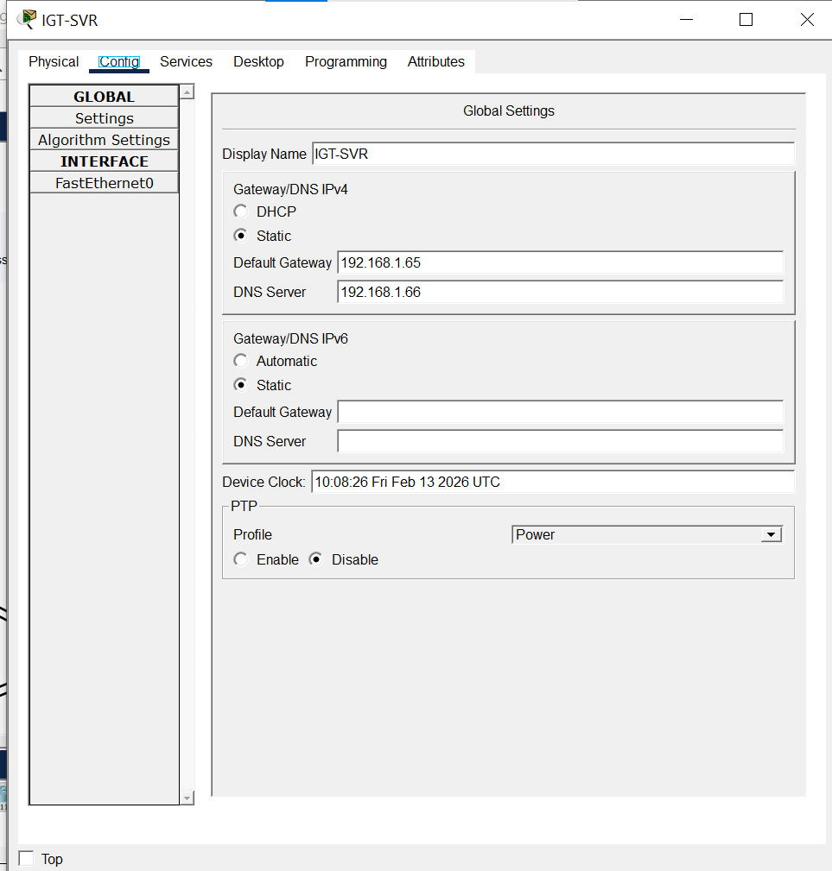

IGT-PC:
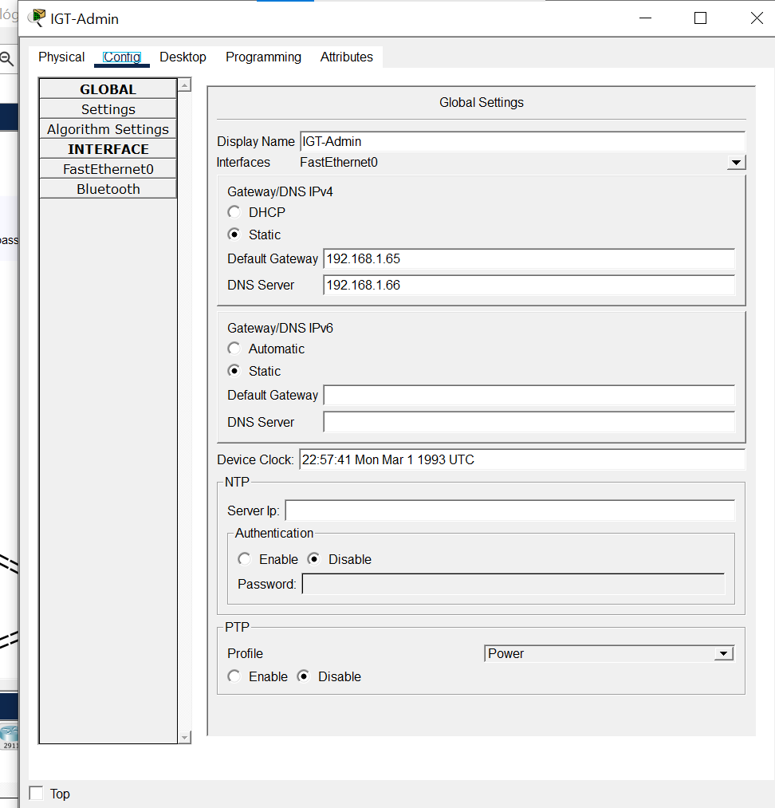
ISP:
ISP#show run
Building configuration...

Current configuration : 1359 bytes
!
version 15.1
no service timestamps log datetime msec
no service timestamps debug datetime msec
no service password-encryption
!
hostname ISP
!
!
!
!
!
!
!
!
no ip cef
no ipv6 cef
!
!
!
!
license udi pid CISCO2811/K9 sn FTX10174AHE-
!
!
!
!
!
!
!
!
!
!
!
!
!
spanning-tree mode pvst
!
!
!
!
!
!
interface FastEthernet0/0
no ip address
duplex auto
speed auto
!
interface FastEthernet0/1
no ip address
duplex auto
speed auto
shutdown
!
interface Serial0/0/0
ip address 203.0.113.1 255.255.255.252
clock rate 2000000
!
interface Serial0/0/1
ip address 203.0.113.5 255.255.255.252
clock rate 2000000
!
interface Serial0/1/0
ip address 203.0.113.9 255.255.255.252
clock rate 2000000
!
interface Serial0/1/1
no ip address
clock rate 2000000
shutdown
!
interface Serial0/2/0
no ip address
clock rate 2000000
shutdown
!
interface Serial0/2/1
no ip address
clock rate 2000000
shutdown
!
interface Serial0/3/0
no ip address
clock rate 2000000
shutdown
!
interface Serial0/3/1
no ip address
clock rate 2000000
shutdown
!
interface Vlan1
no ip address
shutdown
!
router ospf 1
router-id 3.3.3.3
log-adjacency-changes
network 203.0.113.0 0.0.0.3 area 0
network 203.0.113.4 0.0.0.3 area 0
network 203.0.113.8 0.0.0.3 area 0
!
ip classless
!
ip flow-export version 9
!
!
!
!
!
!
!
line con 0
!
line aux 0
!
line vty 0 4
login
!
!
!
end

DEB-RT:
DEB-RT(config)#do show run
Building configuration...

Current configuration : 2043 bytes
!
version 15.1
no service timestamps log datetime msec
no service timestamps debug datetime msec
service password-encryption
security passwords min-length 8
!
hostname DEB-RT
!
!
!
enable secret 5 $1$mERr$vMcrBN/DfPzNMx8ZDobeB0
!
!
!
clock timezone CET 1
!
!
!
!
ip cef
ipv6 unicast-routing
!
no ipv6 cef
!
!
!
!
license udi pid CISCO2811/K9 sn FTX1017J63X-
!
!
!
crypto isakmp policy 10
encr aes 256
authentication pre-share
group 5
lifetime 1800
!
crypto isakmp key HORIZONKULCS address 203.0.113.2
!
!
!
crypto ipsec transform-set BP-DEB esp-aes esp-sha-hmac
!
crypto map HORIZONMAP 10 ipsec-isakmp
set peer 203.0.113.2
set pfs group5
set security-association lifetime seconds 900
set transform-set BP-DEB
match address VPNLIST
!
!
!
!
!
!
no ip domain-lookup
ip domain-name horizonbank.hu
!
!
spanning-tree mode pvst
!
!
!
!
!
!
interface FastEthernet0/0
ip address 192.168.2.1 255.255.255.192
duplex auto
speed auto
ipv6 address FE80::4 link-local
ipv6 address 2001:DB8:ACAD:40::1/64
!
interface FastEthernet0/1
ip address 110.110.110.1 255.255.255.248
duplex auto
speed auto
!
interface Serial0/0/0
no ip address
clock rate 2000000
shutdown
!
interface Serial0/0/1
no ip address
clock rate 2000000
shutdown
!
interface Serial0/1/0
ip address 203.0.113.10 255.255.255.252
crypto map HORIZONMAP
!
interface Serial0/1/1
no ip address
clock rate 2000000
shutdown
!
interface Vlan1
no ip address
shutdown
!
router ospf 1
router-id 4.4.4.4
log-adjacency-changes
network 192.168.2.0 0.0.0.63 area 0
network 203.0.113.8 0.0.0.3 area 0
network 110.110.110.0 0.0.0.7 area 0
!
ip classless
!
ip flow-export version 9
!
!
ip access-list extended VPNLIST
permit ip 203.0.113.8 0.0.0.3 203.0.113.0 0.0.0.3
!
banner motd ^C Az illetektelen hozzaferes TILOS! ^C
!
!
!
!
line con 0
exec-timeout 5 0
password 7 08051F4C362B1128395B021E7A27
logging synchronous
login
!
line aux 0
!
line vty 0 4
exec-timeout 5 0
password 7 08051F4C362B1128241F153B1E7828
logging synchronous
login
transport input ssh
!
!
!
end

DEB-SW:
DEB-SW(config)#do show run
Building configuration...

Current configuration : 1568 bytes
!
version 15.0
no service timestamps log datetime msec
no service timestamps debug datetime msec
service password-encryption
!
hostname DEB-SW
!
enable secret 5 $1$mERr$KyPC0T7sVvvhr8Us5OAP..
!
!
!
clock timezone CET 1
!
no ip domain-lookup
ip domain-name horizonbank.hu
!
!
!
spanning-tree mode pvst
spanning-tree extend system-id
!
interface FastEthernet0/1
!
interface FastEthernet0/2
!
interface FastEthernet0/3
!
interface FastEthernet0/4
!
interface FastEthernet0/5
!
interface FastEthernet0/6
!
interface FastEthernet0/7
!
interface FastEthernet0/8
!
interface FastEthernet0/9
!
interface FastEthernet0/10
!
interface FastEthernet0/11
!
interface FastEthernet0/12
!
interface FastEthernet0/13
!
interface FastEthernet0/14
!
interface FastEthernet0/15
!
interface FastEthernet0/16
!
interface FastEthernet0/17
!
interface FastEthernet0/18
!
interface FastEthernet0/19
!
interface FastEthernet0/20
!
interface FastEthernet0/21
!
interface FastEthernet0/22
!
interface FastEthernet0/23
!
interface FastEthernet0/24
!
interface GigabitEthernet0/1
!
interface GigabitEthernet0/2
!
interface Vlan1
no ip address
shutdown
!
banner motd ^C Az illetektelen hozzaferes TILOS! ^C
!
!
!
line con 0
password 7 08051F4C362A12031103332F7A251E273F
logging synchronous
login
exec-timeout 5 0
!
line vty 0 4
exec-timeout 5 0
password 7 08051F4C3F0D1C23410702573E3B707D66223017
logging synchronous
login
transport input ssh
line vty 5 15
exec-timeout 5 0
password 7 08051F4C3F0D1C23410702573E3B707D66223017
logging synchronous
login
transport input ssh
!
!
!
!
end

DEB-PR:
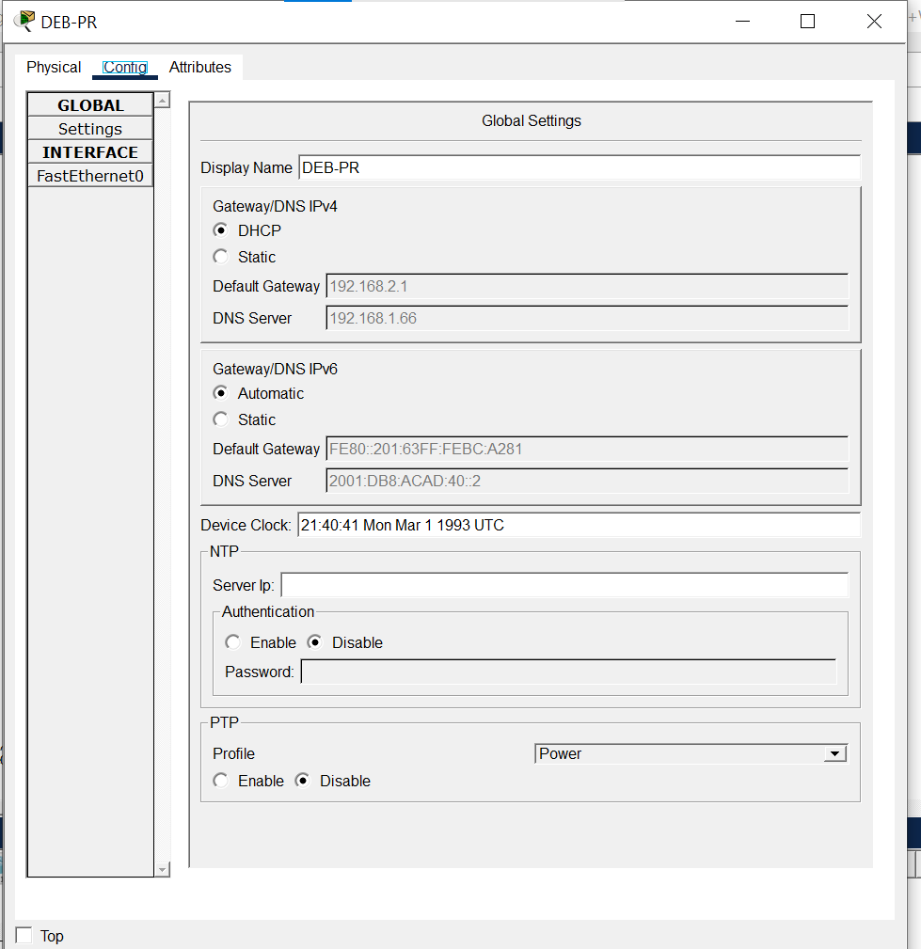

DEB-Admin:
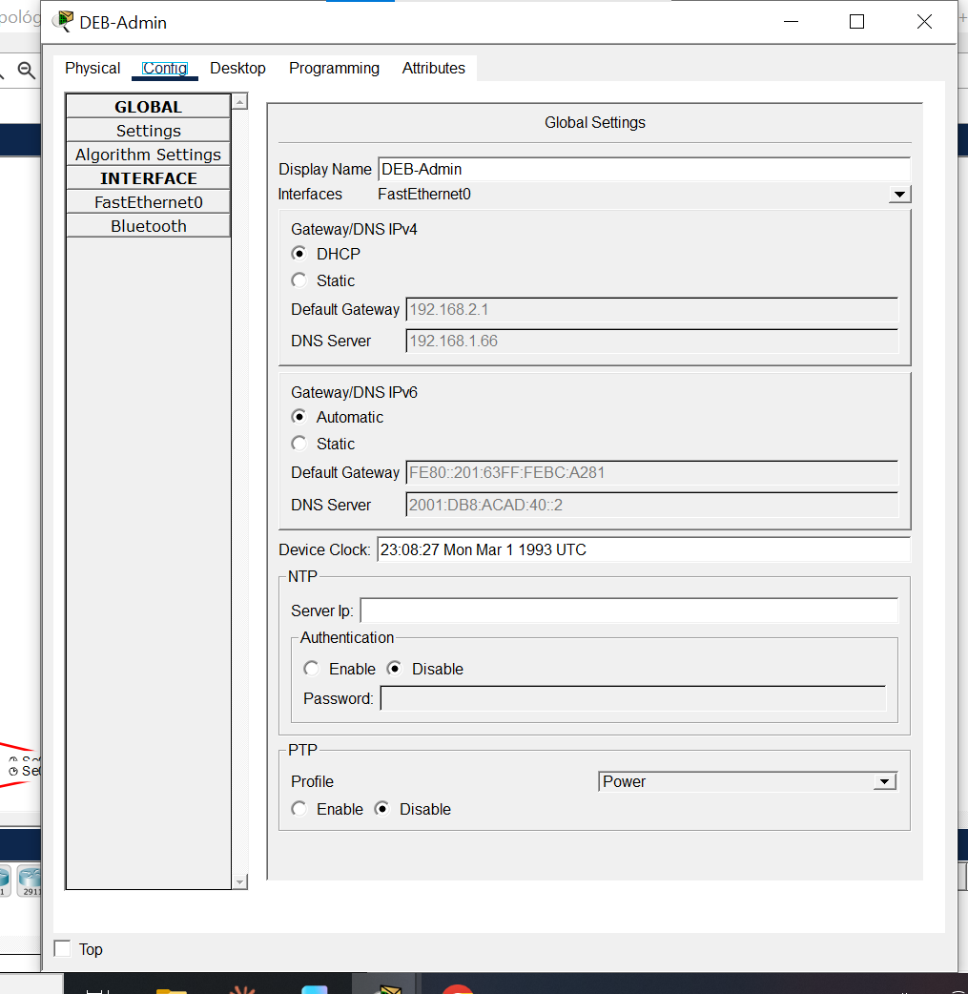

DEB-PC:
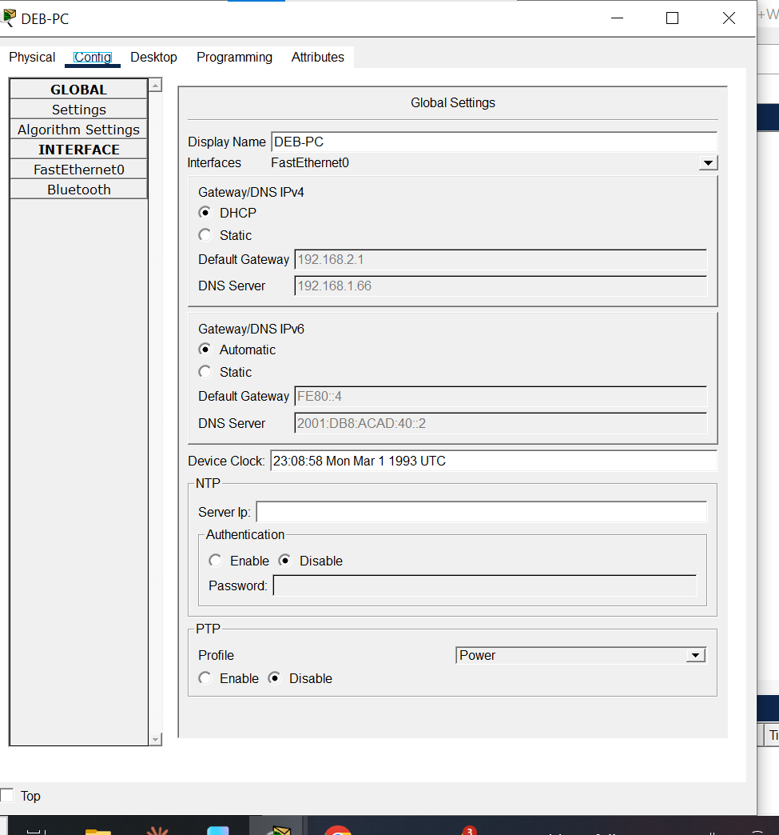

DEB-SVR:
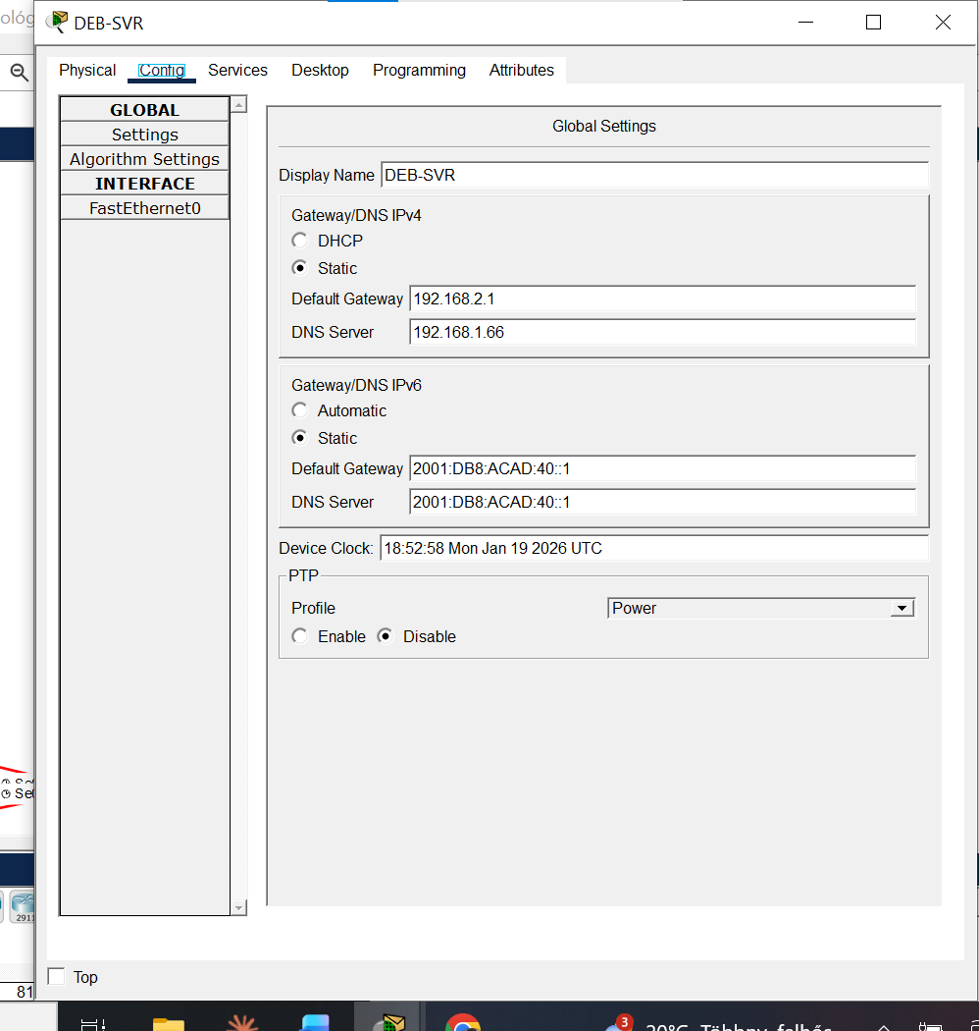

DEB-WR:
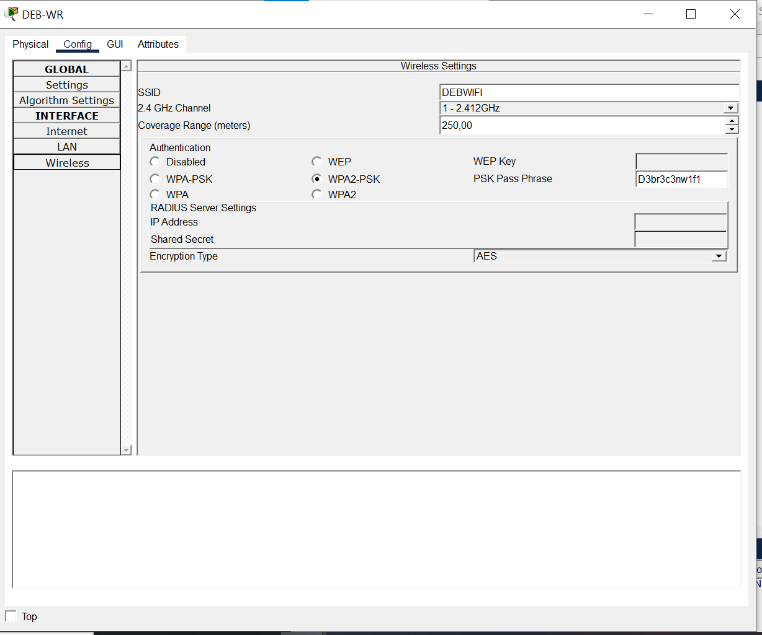
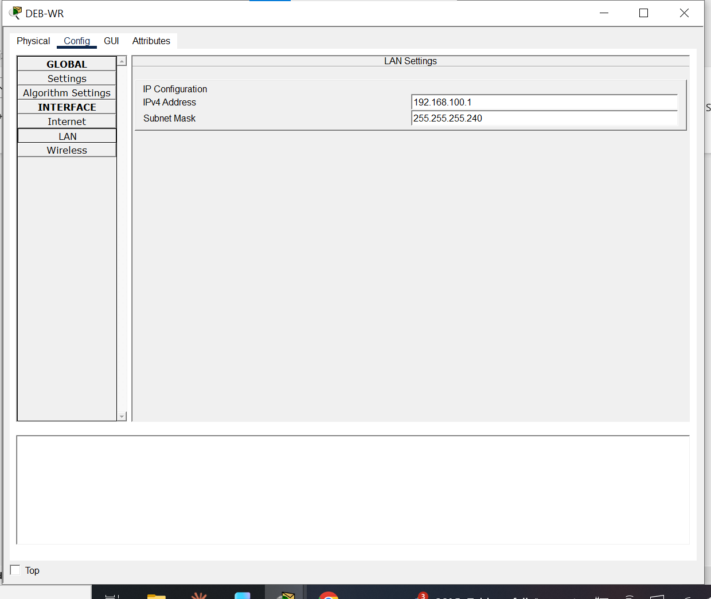
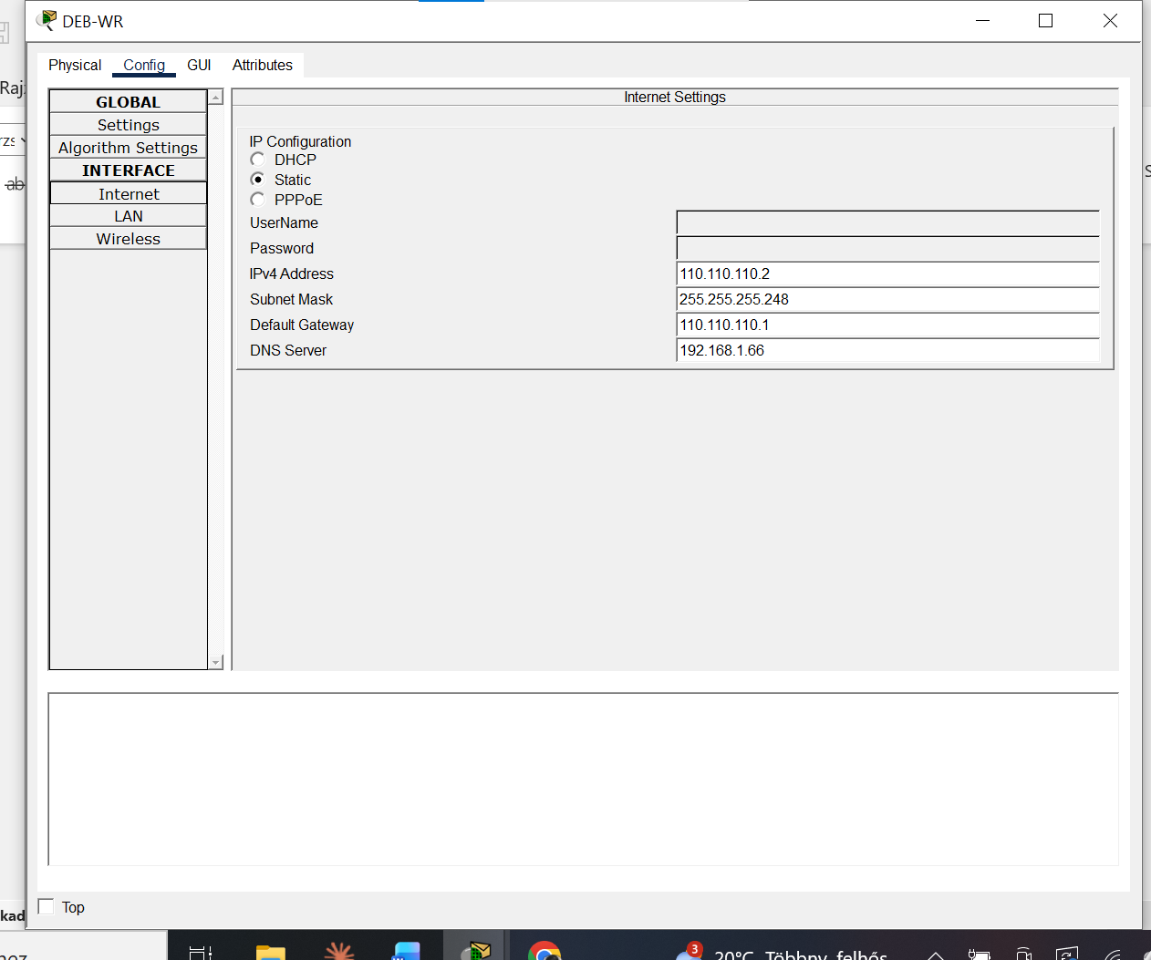

DEB-LTP:
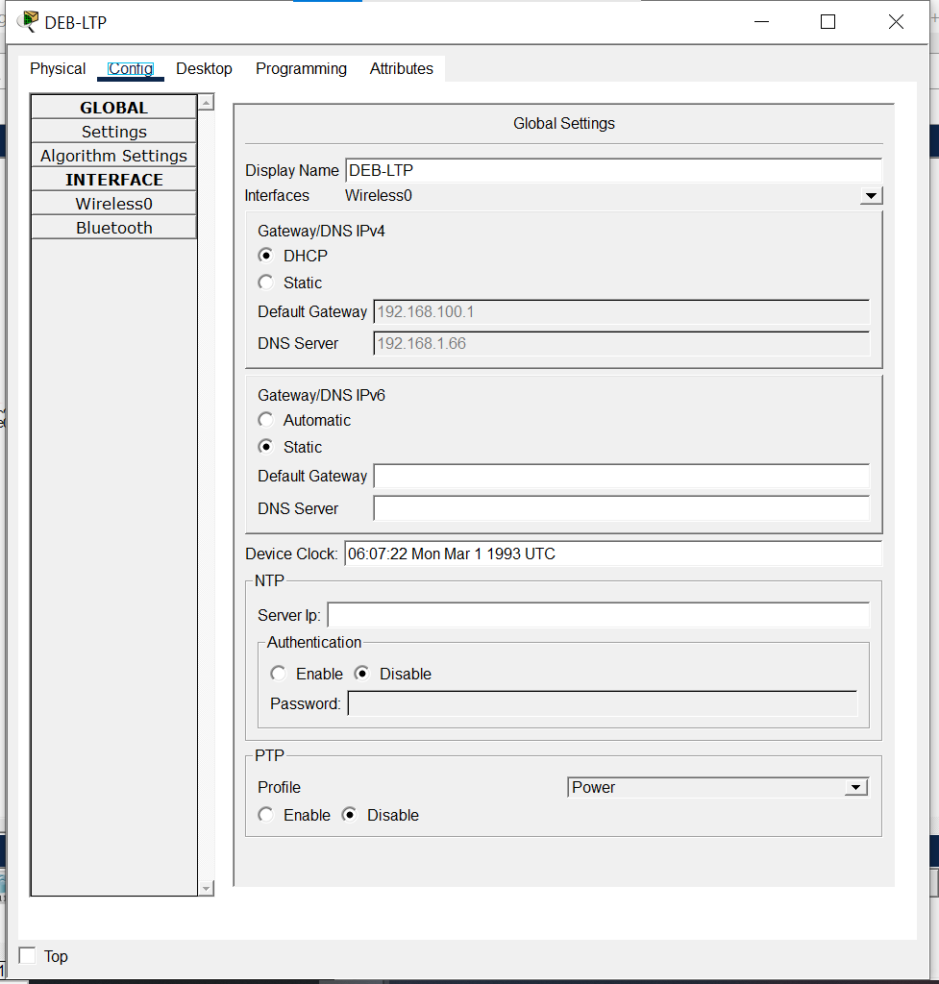
DEB-R-UGYFEL:
VOICE>ena
VOICE#show run
Building configuration...

Current configuration : 1788 bytes
!
version 15.1
no service timestamps log datetime msec
no service timestamps debug datetime msec
no service password-encryption
!
hostname VOICE
!
!
!
!
ip dhcp excluded-address 196.60.60.65
ip dhcp excluded-address 196.60.60.193
!
ip dhcp pool voice
network 196.60.60.64 255.255.255.192
default-router 196.60.60.65
option 150 ip 196.60.60.65
dns-server 192.168.1.66
domain-name horizonbank.hu
ip dhcp pool client
network 196.60.60.192 255.255.255.192
default-router 196.60.60.193
dns-server 192.168.1.66
domain-name horizonbank.hu
!
!
!
ip cef
no ipv6 cef
!
!
!
!
license udi pid CISCO2811/K9 sn FTX10174DAK-
!
!
!
!
!
!
!
!
!
!
!
no ip domain-lookup
!
!
spanning-tree mode pvst
!
!
!
!
!
!
interface FastEthernet0/0
no ip address
duplex auto
speed auto
!
interface FastEthernet0/0.30
encapsulation dot1Q 30
ip address 196.60.60.65 255.255.255.192
!
interface FastEthernet0/0.40
encapsulation dot1Q 40
ip address 196.60.60.193 255.255.255.192
!
interface FastEthernet0/1
no ip address
duplex auto
speed auto
shutdown
!
interface Serial0/3/0
no ip address
clock rate 2000000
!
interface Serial0/3/1
no ip address
clock rate 2000000
!
interface Vlan1
no ip address
shutdown
!
ip classless
!
ip flow-export version 9
!
!
!
!
!
!
!
telephony-service
max-ephones 3
max-dn 3
ip source-address 196.60.60.65 port 2000
auto assign 1 to 9
!
ephone-dn 1
number 1111
!
ephone-dn 2
number 2222
!
ephone-dn 3
number 3333
!
ephone 1
device-security-mode none
mac-address 00D0.BAD7.8036
type 7960
button 1:1
!
ephone 2
device-security-mode none
mac-address 000A.415A.D4B7
type 7960
button 1:2
!
ephone 3
device-security-mode none
mac-address 0000.0C29.D08D
type 7960
button 1:3
!
line con 0
logging synchronous
!
line aux 0
!
line vty 0 4
login
!
!
!
end
DEB-SW-UGYFEL:
SWVOICE#show run
Building configuration...

Current configuration : 1415 bytes
!
version 15.0
no service timestamps log datetime msec
no service timestamps debug datetime msec
no service password-encryption
!
hostname SWVOICE
!
!
!
no ip domain-lookup
!
!
!
spanning-tree mode pvst
spanning-tree extend system-id
!
interface FastEthernet0/1
switchport trunk allowed vlan 1,30,40
switchport mode trunk
!
interface FastEthernet0/2
switchport access vlan 40
switchport mode access
switchport voice vlan 30
!
interface FastEthernet0/3
switchport access vlan 40
switchport mode access
switchport voice vlan 30
!
interface FastEthernet0/4
switchport access vlan 40
switchport mode access
switchport voice vlan 30
!
interface FastEthernet0/5
!
interface FastEthernet0/6
!
interface FastEthernet0/7
!
interface FastEthernet0/8
!
interface FastEthernet0/9
!
interface FastEthernet0/10
!
interface FastEthernet0/11
!
interface FastEthernet0/12
!
interface FastEthernet0/13
!
interface FastEthernet0/14
!
interface FastEthernet0/15
!
interface FastEthernet0/16
!
interface FastEthernet0/17
!
interface FastEthernet0/18
!
interface FastEthernet0/19
!
interface FastEthernet0/20
!
interface FastEthernet0/21
!
interface FastEthernet0/22
!
interface FastEthernet0/23
!
interface FastEthernet0/24
!
interface GigabitEthernet0/1
!
interface GigabitEthernet0/2
!
interface Vlan1
no ip address
shutdown
!
!
!
!
line con 0
logging synchronous
!
line vty 0 4
login
line vty 5 15
login
!
!
!
!
end
